# CS 255 Business Requirements Document

## System Components and Design

### Purpose

*What is the purpose of this project? Who is the client and what do they want their system to be able to do?*

* The purpose of this project is to design a new system for our client, DriverPass, that allows clients to purchase a program to better prepare for their driving test, as there is a need arising in the market due to the percentage of clients who fail their driving test.
* DriverPass wants to design a new system that allows the client to choose a package that will give the client access to on-the-road training, along with an online class with practice tests.

### System Background

*What does DriverPass want the system to do? What is the problem they want to fix? What are the different components needed for this system?*

* DriverPass would like the new system to be able to have clients access it via the web to sign up for a package, to include the client’s information.
* The new system would also allow the clients to log into their account to schedule a driving session, take online classes and tests, see the status of their tests, and view their driver notes.
* The new system would allow clients to reset their account passwords automatically.
* The new system would allow the secretary to enter the client’s information if the client does not wish to register online.
* By creating this new system, DriverPass hopes to allow more clients to be successful when attempting their driving test with the DMV.
* DriverPass would like the DMV and their system linked so the latest requirements from the DMV will be updated.
* DriverPass wants the system to be run off the cloud so they do not have to deal with backup and security.
* DriverPass would like to access data from any computer or mobile device.
* DriverPass would like the ability to disable a package.
* DriverPass will have ten cars with drivers available to schedule at two-hour increments.

### Objectives and Goals

*What should this system be able to do when it is completed? What measurable tasks need to be included in the system design to achieve this?*

* DriverPass will offer three packages:
  + Package One: Six hours in a car with a trainer
  + Package Two: Eight hours in a car with a trainer and an in-person lesson where they explain the DMV rules and policies
  + Package Three: Twelve hours in a car with a trainer, an in-person lesson where they explain the DMV rules and policies – plus access to online classes with all the content and material. The online class also includes practice tests.
* Clients will be able to access the new system via the web or they can call to purchase a package.
* The boss (Liam) and IT officer (Ian) will have access to change user permissions, track user changes, and update/maintain the system.
* 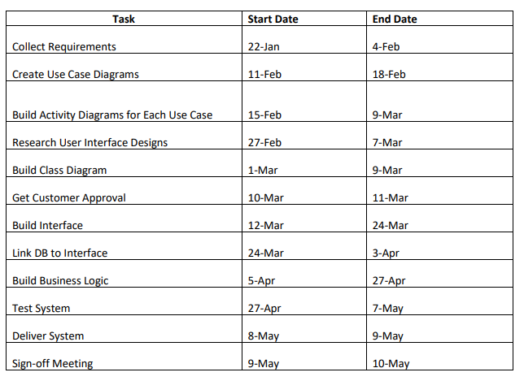The proposed timeline is as follows:
* The tasks shall be assigned and broken down to each team member to contribute to the new systems creation promptly.
* On March 11, the small consulting company will meet with DriverPass to gain their approval over what has been designed so far. If DriverPass requests any changes or updates, the timeline will be pushed out to accommodate those requests to produce the desired product.

## Requirements

### Nonfunctional Requirements

#### Performance Requirements

*What environments (web-based, application, etc.) does this system need to run in? How fast should the system run? How often should the system be updated?*

* The environment will need to be web-based, preferably over the cloud.
* Even with the web-based environment, the system will need to be able to be accessed from anywhere, including offline.
* The environment must be mobile-friendly, including Android and Apple platforms.
* The system should get a notification whenever the DMV makes any changes or updates so that they can be included in their system.
* The system should be able to handle customer traffic, both through the web and mobile applications.

#### Platform Constraints

*What platforms (Windows, Unix, etc.) should the system run on? Does the back end require any tools, such as a database, to support this application?*

* The system should be compatible with all platforms via the cloud.
* The database should allow user information to be stored and accessed when the user logs into their account.

#### Accuracy and Precision

*How will you distinguish between different users?* *Is the input case-sensitive? When should the system inform the admin of a problem?*

* Each user will need to create an account with different permissions based on the type of account created. The administrators will be able to control each user’s account type.
* For security reasons, the input will be case-sensitive.
* The system should inform the admin of a problem immediately. Ian, the IT officer, is responsible for maintaining the system, modifying it, and identifying/solving any issues.

#### Adaptability

*Can you make changes to the user (add/remove/modify) without changing code? How will the system adapt to platform updates? What type of access does the IT admin need?*

* The admin can make changes to the user (add/remove/modify) based on the business needs.
* The IT department, or Ian, will maintain the site and push small updates as needed for each platform or updates related to the business and DMV.
* IT admin will have full permission.s However, the system will track what user performed what changes.

#### Security

*What is required for the user to log in? How can you secure the connection or the data exchange between the client and the server? What should happen to the account if there is a “brute force” hacking attempt? What happens if the user forgets their password?*

* There should be a multifactor authentication prompted when the user logs in.
* The cloud must ensure a secure connection with the data exchange between the client and server.
* If there is a “brute force” hacking attempt, the account should be disabled after five incorrect login attempts.
* If users forget their password, they must answer a security question and/or have a password reset link emailed to the email address on file. If they are still unsuccessful at logging in, they must speak to DriverPass in person to unlock their account.

### Functional Requirements

*Using the information from the scenario, think about the different functions the system needs to provide. Each of your bullets should start with “The system shall . . .” For example, one functional requirement might be, “The system shall validate user credentials when logging in.”*

* The system shall validate user credentials when logging in.
* The system shall allow users to book reservations without overlapping existing reservations.
* The system shall provide practice tests and allow users to see previous test scores.
* The system shall provide the user of the different driving packages with the option to upgrade their package.
* The system shall show the user their progress.
* The system shall show the user their upcoming and past reservations and with what driver they were paired.
* The system shall run efficiently and be aligned with the DMV.
* The system shall work on all platforms via the cloud.
* The system shall provide sufficient security guarding data against any attacks.
* The system shall allow one account per user.
* The system shall allow different users different permissions based upon their account set up. (Secretary, customer, administrator, IT).
* The system shall track any changes made to an account or the system.

### User Interface

*What are the needs of the interface? Who are the different users for this interface? What will each user need to be able to do through the interface? How will the user interact with the interface (mobile, browser, etc.)?*

* The interface must allow the customer to access driver notes, update their personal information, add a student photo, add any special needs, show online test progress, show online tests, and schedule with a drive.
* The interface must allow administrators to disable and update new packages, change account permissions, and pull up reports online and offline.
* The interface must allow employees to view their schedule for driver appointments, reserve an appointment over the phone or in person, and allow customers to register for an online profile over the phone or in person.
* The interface must allow IT to add or remove modules, update the system, troubleshoot, and pull reports as needed.
* The user should be able to interact with the web-based application online or through a mobile device. This application should be available online and able to view offline.

### Assumptions

*What things were not specifically addressed in your design above? What assumptions are you making in your design about the users or the technology they have?*

* No budget was given for this project.
* There was no detailed way of how they will receive updates from the DMV.
* It is assumed that all customers can access a computer or mobile device.
* Customers cannot register for an account online, as DriverPass has stated they want the customer to call to create an account.

### Limitations

*Any system you build will naturally have limitations. What limitations do you see in your system design? What limitations do you have as far as resources, time, budget, or technology?*

* Some limitations include scope, cost, time, quality, and resources.
* If DriverPass decides to change or add to a requirement, the project's time must be adjusted accordingly.
* There is a scope restraint as no process is set up to manage changes.
* There is no budget set for this project. Therefore, it is important to determine if what DriverPass desires is affordable and can be implemented.
* The system must be able to function on multiple platforms and run on the cloud.

### Gantt Chart

